**Lab 1 Assignment**

**Aim:** Study of Various Virtualization Software such as VMware, QEMU, KVM, XEN Hypervisor and Oracle Virtual Box.



1. **Compare their Virtualization type and methodologies.**

**Virtualization Types**

1. **Full Virtualization**

* This technique emulates the complete hardware environment
* Allows any guest OS to run on the VM
* VMware and VirtualBox utilize Full Virtualization

1. **Para Virtualization**

* This technique modifies the guest OS to interact with the Hypervisor
* Offers better performance than full virtualization but requires compatibility between guest OS and Hypervisor
* Xen and KVM utilize Para Virtualization

1. **Hardware assisted Virtualization**

* This technique leverages special features built into modern processors to improve virtualization performance and security
* Features like translating guest OS memory addresses to physical memory addresses.
* VMware ESXi and Xen utilize hardware assisted virtualization.

**Methodologies**

1. **VMware**

* Uses a technique called hardware-assisted virtualization where it leverages features provided by modern CPUs (Intel VT-x or AMD-V) to improve the efficiency of virtualization

1. **QEMU**

* QEMU utilizes dynamic binary translation to emulate the guest CPU instructions
* Dynamic binary translation is particularly useful in scenarios where direct execution of guest instructions on the host is not feasible due to architectural differences. This process occurs dynamically at runtime, translating the binary code of guest instructions to equivalent instructions that can be executed on the host system

1. **KVM**

* KVM leverages hardware virtualization extensions (Intel VT-x or AMD-V) to provide a direct interface to the host's CPU for virtualization. It works as a kernel module and relies on the Linux kernel's scheduler and memory management.

1. **XEN Hypervisor**

* Xen uses a microkernel design where the hypervisor runs as a separate, lightweight kernel (the "Xen hypervisor") above the hardware. It allows multiple operating systems to run concurrently in isolated domains (known as Xen domains or VMs). Each domain has its own kernel, and the hypervisor manages their access to hardware resources.

1. **Oracle VirtualBox**

* VirtualBox runs as a user-space application on the host operating system. It uses a combination of dynamic binary translation and various device drivers to emulate hardware and provide a virtualized environment for guest operating systems

1. **Identify architectural difference.**

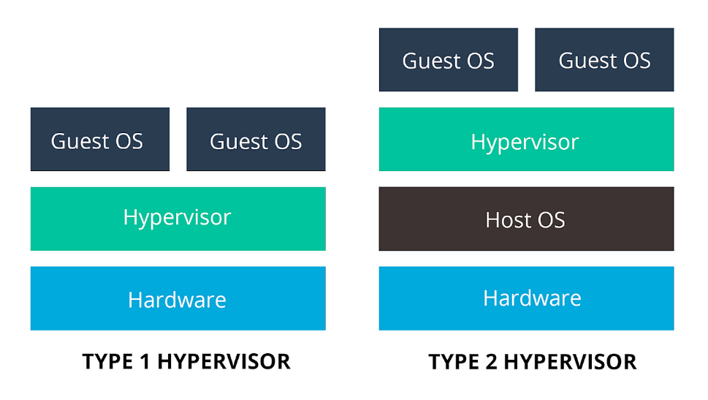

|  |  |  |  |  |  |
| --- | --- | --- | --- | --- | --- |
| **Software** | **VMware** | **QEMU** | **KVM** | **Xen** | **Oracle VirtualBox** |
| **Type** | Type 1 (bare-metal) and Type 2 (hosted) | Type 1 (bare-metal) and Type 2 (hosted) | Type 2 (hosted) | Type 1 (bare-metal) and Type 2 (hosted) | Type 2 (hosted) |
| **Focus** | Enterprise virtualization, desktop virtualization, cloud computing | Machine emulation, basic virtualization | Open-source virtualization for Linux | Open-source cloud infrastructure, server virtualization | Free personal virtualization, educational tool |
| **Pros** | Robust features, high performance, advanced security | Open-source, highly flexible, good for emulation | Free, open-source, efficient for Linux | Open-source, widely used in cloud, robust features | Free, cross-platform, easy to use |
| **Cons** | Can be expensive, complex to manage | Limited features in hosted version, not ideal for high-performance workloads | Requires Linux kernel, not as user-friendly as some options | Less mature than some Type 1 hypervisors, may not be suitable for all workloads | Limited features compared to some enterprise solutions |

1. **List out various advantages, disadvantages and applications.**
2. **VM Ware**

**Advantages:**

* Management Tools: Comprehensive management tools like vSphere, advanced features such as vMotion for live migration.
* Compatibility: Wide compatibility with various operating systems and Widely used in enterprise environments

**Disadvantages:**

* Cost Concerns: VMware can be expensive due to licensing fees, which might be challenging for smaller businesses.
* Limited Flexibility: VMware's proprietary nature can limit customization options compared to open-source alternatives.

**Applications:**

* Server Virtualization: VMware is extensively used for server virtualization, allowing multiple virtual machines (VMs) to run on a single physical server.
* Desktop Virtualization: VMware provides solutions for desktop virtualization, enabling organizations to centralize desktop management and delivery.
* Cloud Computing: VMware's virtualization technology is used in building and managing cloud infrastructures.

1. **QEMU**

**Advantages:**

* Emulation: Can emulate various hardware devices beyond virtualization, ideal for testing and development.
* Lightweight: Less resource-intensive than some other options, suitable for lower-powered environments.

**Disadvantages:**

* Speed Issues: QEMU may not be as fast as other options, especially in situations where a lot of resources are needed.
* Not User-Friendly: Setting up QEMU can be complex, especially for those who prefer graphical interfaces over command lines.

**Applications:**

* Emulation: QEMU is often used for hardware emulation, allowing software to run on platforms for which it was not originally designed.
* Cross-Platform Development: Developers use QEMU to test software on different architectures without the need for physical hardware.
* System Recovery: QEMU can be employed for system recovery and backup purposes.

1. **KVM**

**Advantages:**

* Built-in: Included in the Linux kernel, providing seamless integration and native performance.
* Open-source: Free and community-driven, making it accessible and customizable.

**Disadvantages:**

* Linux Focus: KVM works best with Linux, which may be a drawback for environments where Linux isn't the main operating system.
* Hard to Set Up: Getting KVM up and running can be complicated, especially for users unfamiliar with Linux.

**Applications:**

* + Performance: KVM can provide high-performance virtualization by leveraging hardware support.
  + Cloud Computing: KVM is widely used in cloud computing environments, providing a robust and efficient virtualization solution.
  + Flexibility: Supports a wide range of guest operating systems.

1. **XEN Hypervisor**

**Advantages:**

* Type-1  hypervisor: Offers **high performance** and isolation for critical workloads.
* Security focus: Designed with security in mind, incorporating features like **memory paging** and security domains.

**Disadvantages:**

* Limited Graphics Support: Xen traditionally has **limited support** for **graphics-intensive applications**.
* Lack of USB Passthrough Support: Xen has faced **challenges** with **USB passthrough** support.

**Applications:**

* Server Consolidation: Xen is used for server consolidation, allowing **multiple virtual servers** to run on a single physical server.
* Cloud Hosting: Xen is utilized in many **cloud hosting platforms** to provide virtualized instances to users.
* Isolation: Xen's architecture provides **strong isolation** between virtual machines, enhancing security.

1. **Oracle VirtualBox**

**Advantages:**

* Free and easy to use: Ideal for individual users and smaller deployments.
* User-friendly interface: Simple and intuitive for beginners to set up and manage VMs.

**Disadvantages:**

* Performance Drawbacks: VirtualBox might not handle high-demand situations as well as some other options.
* Lacking Advanced Features: VirtualBox may lack some advanced features found in solutions like VMware, which could be a drawback for enterprise users.

**Applications:**

* Desktop Virtualization: VirtualBox is commonly used for desktop virtualization, enabling users to run multiple operating systems on a single physical machine.
* Development and Testing: VirtualBox is popular for development and testing environments, allowing developers to create and test applications on various operating systems.
* Education and Training: VirtualBox is used in educational settings to create virtual labs and facilitate hands-on training in different operating systems.